# COMP7500/7506 Lecture 05: Project 2 A Pipe-based WordCount Tool

**🟊: >85%, 🟊🟊: 70-85%, 🟊🟊🟊: 55-70%, 🟊🟊🟊🟊: 40-55%, 🟊🟊🟊🟊🟊: < 40%**

**🟊 Exercise 1:** We will implement the WordCount tool as a command-line (i.e., pwordcount). What is (are) WordCount’s argument(s)?

**🟊🟊🟊 Exercise 2:** User input should be checked for errors. What error-checking cases should you consider in pwordcount with respect to user input?

**Exercise 3: Read the following source code.**



**🟊 3.1 (Plickers)** What is the value of child process pid?

A) -1 B) 0 C) 1 D) A Random Value

**🟊🟊🟊 3.2:** What is the output of this program?

**Exercise 4:** Read the following source code



**🟊 4.1 (Plickers)** What is the data structure of fd?

A) integer B) file directory C) integer array D) file array

**🟊🟊 4.2 (Plickers)** Is fd an input or output of pipe()?

A) output B) input C) error code D) none of the above

**🟊🟊 Exercise 5 (Plickers):** Read the following source code

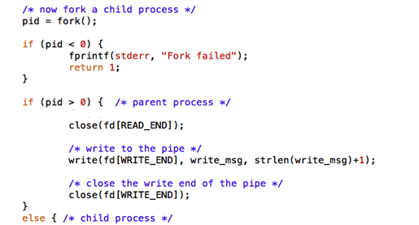

Why close fd(READ_END)?

1. Must be closed before writing to the pipe.
2. READ_END hasn’t yet been opened
3. We finish using READ_END
4. It is an unused end of the pipe

**🟊🟊🟊 Exercise 6:** What are the three arguments in read()?